Grand Lodge

RICKY L. LAWLER
Grand Lecturer
P.O. BOX 806
GALT, CA 95632-0806
(209) 365-3697
rlawlerx5@softcom.net

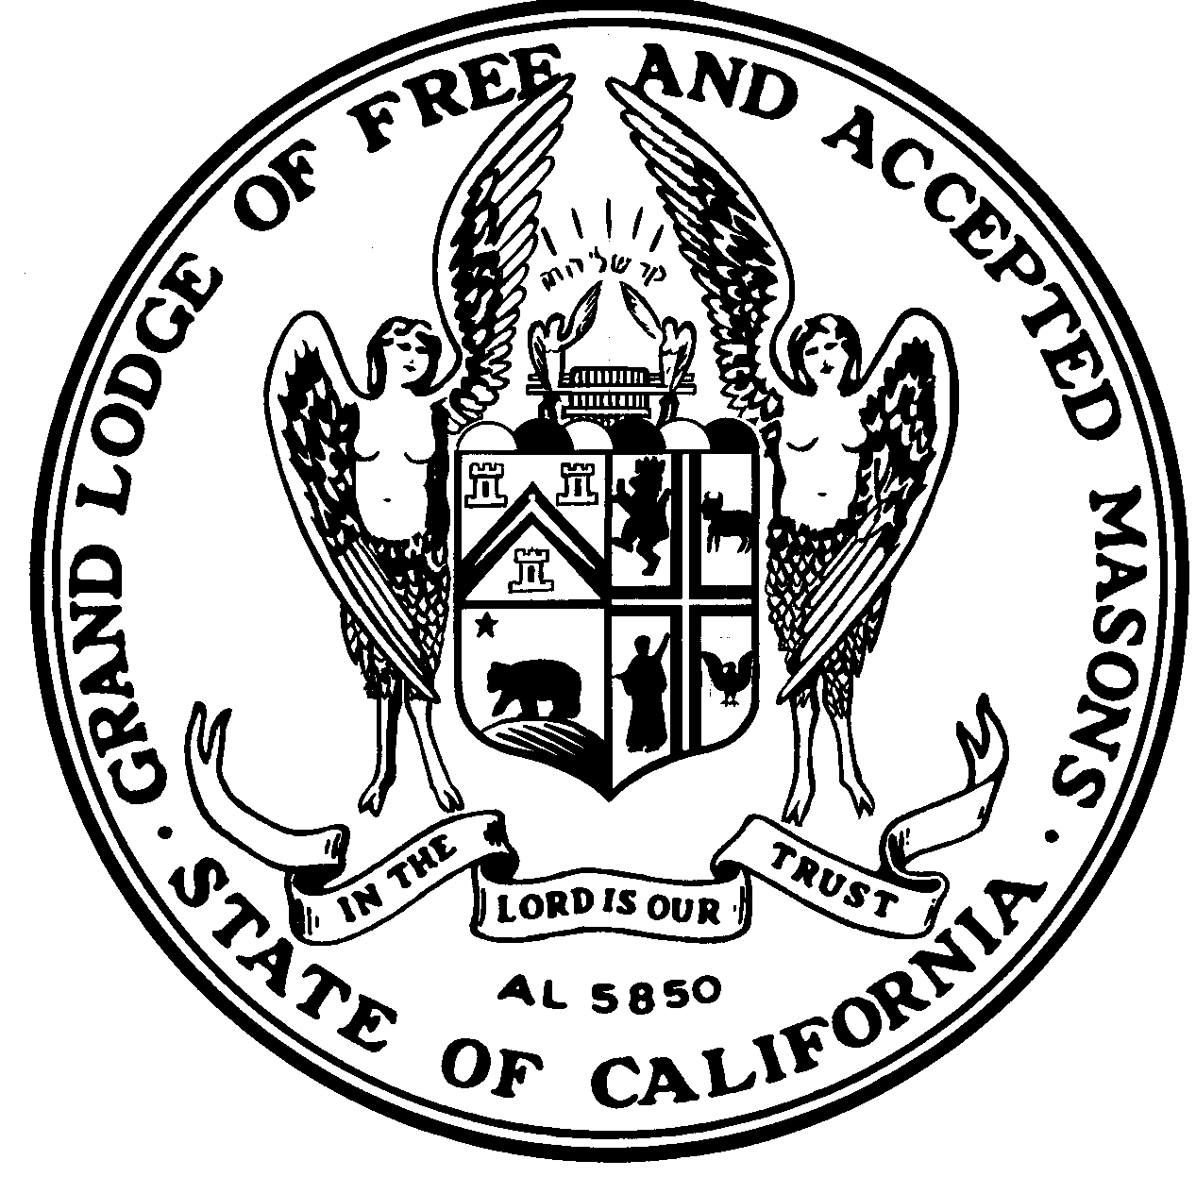

Free and Accepted Masons

of California
CALIFORNIA MASONIC MEMORIAL CENTER
1111 CALIFORNIA STREET
SAN FRANCISCO, CA 94108-2284
(415) 776-7000

January 30, 2019

TO: LODGE MASTERS, WARDENS, AND SECRETARIES

SUBJ: USE OF DIGITAL MUSIC WITHIN OUR LODGES

I was raised in a lodge that was blessed to have music. Music creates the atmosphere of solemnity within our lodges and enhances our ritual. Our memories become more vivid when events are associated with music.

Unfortunately, many of our lodges do not have a talented brother who can provide the music for our events. Many degrees and stated meetings within these lodges proceed in relative silence. It is hoped that our lodges never cease in their search for talented brothers willing to perform music, but in the interim, technology has offered an alternative.

Music can be provided via a smartphone or tablet connected to a speaker system, preferably one that is Bluetooth enabled. Music pieces are available for use in these systems. With these possibilities, there are some parameters that must be followed:

- A brother providing the music must be independent and not be a participant in
the ritual of the degree.

- The brother providing the music must attend lodge ritual practices to ensure the proper timing.

- The music must be appropriate for the event and those portions of the degree.

Please discuss your use of appropriate music within your lodge with your district inspector. He has access to further administrative guidelines developed by the Ritual Committee for the use of all music within our lodges.

Our Past Grand Lecturer, the Very Worshipful Jack Rose has made contact and received written permission from our New Zealand brethren to access and use their music in California. Links to access music:

Link No. 1:
https://files.mycloud.com/home.php?seuuid=74470da703b03a17d7137593284a348b&name=Masonic%20Music&brand=webfiles

Link No. 2:
https://files.mycloud.com/home.php?seuuid=d9f22179ae08b0c5fb56d71c3655052f&name=Music%20for%20Masons&brand=webfiles

The Grand Lodge of New Zealand has graciously granted written permission for the use of music they have produced at these links, and we Thank the following for their contributions:

· Grand Lodge of New Zealand Northern Division Masonic Choir who originally supplied
funding for the CD music.
· VW Bro Brian Crone Past Grand Organist for the organ music.
· VW Bro James Morton Past Grand Lecturer for the various horn pieces.
· VW Bro Ian Barron Past Divisional Grand Director of Ceremonies for the CD
production and recordings.
· W Bro Peter Howie Past Grand Steward for Organ music

Ricky L. Lawler, PM
Grand Lecturer

RL:rl

