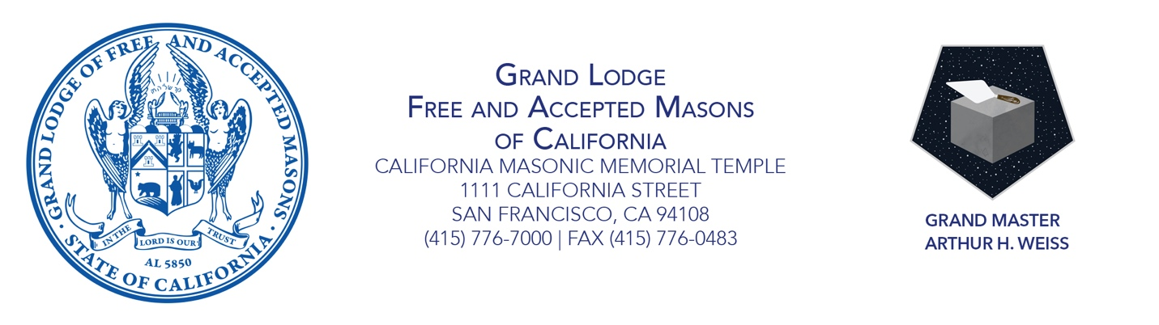
GRAND MASTER’S PROCLAMATION
JULY 2021 IS SUPPORT OUR VETERANS MONTH
Embracing the Next Evolution

Whereas California is home to some 1.56 million veterans of military service, most of any state in the nation; and

Whereas veterans face increased challenges upon returning to civilian life, including heightened rates of physical and emotional health problems, homelessness, and substance abuse; and

Whereas California Masons recognize the service and sacrifice that veterans of our military have made for our country;

As grand master I therefore proclaim July 2021 is Support Our Veterans Month.

As California Masons, we honor those who have served our country as members of our military during both peace and wartime. This month, during which we celebrate our nation’s independence, I call on our Masonic lodges to recognize the veterans in their communities and to salute them through volunteerism, donations, or lodge events. Thank you to our veterans for your service to the country.

Sincerely and fraternally, Attest:

Grand Master Arthur H. Weiss Grand Secretary Allan L. Casalou

