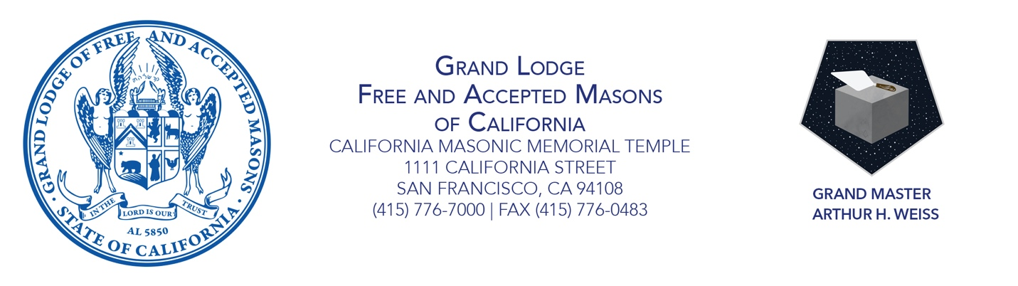
GRAND MASTER’S PROCLAMATION
JUNE 2021 IS MASONIC HOMES MONTH
Embracing the Next Evolution

Whereas Masons have taken a pledge to support all brothers and their wives, widows,
and children in their hour of need; and

Whereas for more than 100 years, the Masonic Homes of California has provided compassionate, relevant, and critical services to Masons and their families; and

Whereas residents of the Masonic Homes represent one of the most at-risk groups during the Coronavirus pandemic, who now more than ever require the support of our fraternity; and

Whereas Masonic Outreach Services plays a crucial role in connecting vulnerable Masons and their family members to local and immediate forms of relief; and

Whereas the Masonic Center for Youth and Families provides children, teens, and adults important counselling services and tools for maintaining mental health and emotional wellness; and

Whereas the Masonic Homes, MOS, and MCYAF have provided Masons from around the state with important services during the Coronavirus pandemic and subsequent shutdown;

As grand master, I therefore proclaim June 2021 to be Masonic Homes Month in California.

Since 1898, California Masons have fulfilled their obligation to care for fellow members and their families through their support of the Masonic Homes. More than a century later, the fraternity remains committed to delivering on that promise by offering crucial services to those in need through retirement homes in Union City and Covina, through Masonic Outreach Services throughout the state, and through MCYAF in San Francisco and Covina. This month, I call on Masons to support these important programs—and to make sure that all members are aware of the benefits they are entitled to as Masons and widows. Share the Masonic Assistance Line (888-466-3642) with members in need; visit the Masonic Homes online to learn about the services being offered; and of course make a gift to the Masonic Homes to ensure that this proud legacy endures into the future.

Sincerely and fraternally, Attest:

Grand Master Arthur H. Weiss Grand Secretary Allan L. Casalou

