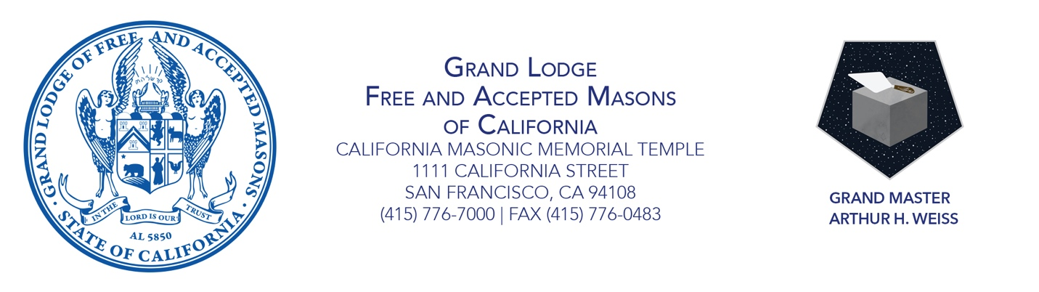

GRAND MASTER’S PROCLAMATION

MAY 2021 IS **PUBLIC AWARENESS MONTH**

*Embracing the Next Evolution*

**Whereas** California Masons perform untold hours of service to improve their communities, and raise important funds to support the most vulnerable members of our communities; and

**Whereas** the next evolution of Freemasonry is predicated on the growth and vitality of our fraternity; and

**Whereas** misconceptions about Freemasonry endure in popular culture, which hamper the positive change we hope to make in our communities;

**As grand master, I therefore proclaim May 2021 is Public Awareness Month in California.**

An important aim of the 2025 Fraternity Plan includes increasing awareness in our communities of the fraternity and the work that Masons all over California do in their towns. Raising awareness of the fraternity means countering negative assumptions about Masonry; talking openly with friends, family, and colleagues about what membership in Masonry means; and showing the world why our organization is and remains relevant today. I encourage all members and lodges to consider ways that they can raise awareness of Freemasonry in their community—through open houses, tabling opportunities, and simple conversations with friends and family. California Masons have much to be proud of. It’s time we share that pride with more of the outside world.

Sincerely and fraternally, Attest:

Grand Master Arthur H. Weiss Grand Secretary Allan L. Casalou